DEPARTMENT OF BOTANY
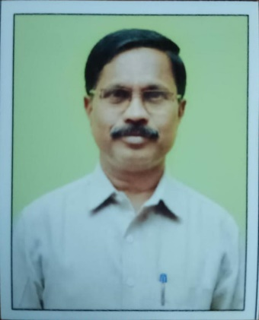
PERSONAL DETAILS
G.BHOJAPPA M.Sc.,M.Phil.,
S/O G.MAREPPA
4 MAY 1966
LECTURER IN BOTANY
N.S.P.R GDC(w), Hindupur
TEL : 9441669533
MAIL : gbhojappa@gmail.com

TEACHING EXPERIENCE

25 Years

Course | Name of the Working College | Years
UG (BSc) | SDGS College Hindupur | 1998-2021
UG (BSc) | NSPR GDC(W) Hindupur | 2021-

FACULTY AS A MEMEBRS IN

- Sri.G.Bhojappa BOS Chairman (UG Programme, S.K. University,Anathapuramu)
- Convenor and Member in different institutional committees.

PROFESSIONAL EXPERIENCE

S.No | Orientation/Refresher course | Organised by | Year
01 | Orientation Course | ASC,Banglore  University,Benglore | 28-01-2002 to 23-02-2002
02 | Refresher Course in Botany | ASc,Barathair University,Coimbatore | 13-09-2002 to 03-10-2002
03 | Refresher Course in Life Sciences | ASC,Mysore University,Mysore | 07-01-2004 to 27-01-2004
04 | Refresher Course in Bio Technology | RC- SK University, Ananthapuramu | 19-10-2005 to 08-11-2005
05 | Faculty Development Programme | ASC, University of Hyderabad,Hyderabad | 15-11-2010 to 20-11-2010

PROFESSIONAL SKILLS

S.No | Programme | Organised by | Date
01 | Electrophoretic and Culture Techniques(Department of Life Sciences) | Govt.College Ananthapuramu | 10-04-2014
02 | Nationa Workshop-Ethno Botany Traditional Knowledge-Access and Benefits Sharing | SPW College,Tirupathi | 01-09-2014 to 03-09-2014
03 | Workshop on Mashroom Cultivation | Department of Botany,SV University,Tiripathi | 12-11-2014 to 13-11-2014
04 | National Symposium on National Products and Bio Diversity-our Insurance for the Future(paper Presented) | Govt.College for Men Kurnool and Science and Tech.Foundation Benglore | 12-12-2014
05 | Lecture Workshop on Recent Advances in Plant Taxonomy,Conservation and Ethno Biology | Department of Botany,SSBN Degree College,(Autonomous) Ananthapuramu | 14-12-2016 to 15-12-2016
06 | National Symposium on Prospectus and Potential in Medicinal and Aronamatic Plants | Department of Botany Govt College,Ananthapuramu(A) and Sciences Tech. Foundatio Bengalore | 19-12-2015
07 | National Seminar on Bio-Diversity,Conservation,Emerging Trends and Challenges | Department of Zoology,Govt College Ananthapuramu(A) and UGC | 05-12-2017 to 16-12-2017
08 | National Conference on Academia Digital Transformation(challenges and opportunities) | IQAC,SSBN Degree College,(Autunomous) Ananthapuramu. | 15-12-2017 to 16-12-2017
09 | National Conference on Strategizing Teaching Learing for Quality Enhancement and Sustenance | Sindhi College, Bengalore with Association of NAAC,Banglore. | 22-03-2019 to 23-03-2019
10 | National Workshop on Hydroponics | Department of Botany SV University Tirupathi. | 28-11-2019
11 | National web Conference on Impact of Environmental Factors for plants and human genetics | University of Horticultural sciences Bagalkot and SDUAHER | 13-10-2020
12 | Three days Training Programme on Internship and LMS | CCE and NRC Govt Degree Colllege(A) Anathapuramu | 06-02-2023 to 08-02-2023
13 | Six days Training of Trainees Programme (TOT) | NRC Govt Degree College(A) Ananthapuramu. | 12-02-2023 to 17-06-2023

FACULTY DEVELOPMENT PROGRAMME

SNo | Programmme | Organised by | Date
01 | Five days Faculty Development Programme in Botany(webinar) | Commisionerate of Collegiate Education,Govt of AP | 13-07-2020 to 17-07-2020
02 | Three days Faculty Development Programme on Revised assessment and Accrediation framework of NAAC. | Department of Botany Y.V University,Kadapa | 12-09-2020 to 14-08-2020
03 | Seven days Online faculty development programme on plants for food and health care | Andhra Christian College,Guntur and APSCHE | 09-09-2020 to 15-09-2020

RESEARCH EXPERIENCE

4 Years 5 Months on PLANTS TISSUE CULTURE & CO2 Cequestration(TOF).

